Welcher Switch wird in dem folgenden Netzwerk(Abbildung 1) die Root-Bridge und welcher Port wird deaktiviert? Begründen Sie Ihre Entscheidung und bezeichnen Sie alle Ports.
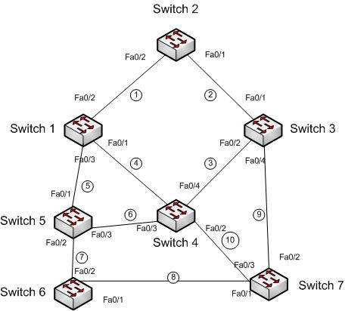
Switch 1 00:0F:56:BC:EE:6B
Switch 2 00:0A:47:11:05:06
Switch 3 00:0C:02:03:04:05
Switch 4 00:0E:01:01:02:02
Switch 5 00:03:00:11:12:01
Switch 6 00:05:12:AE:32:01
Switch 7 00:07:1C:CA:BC:32

Verbindung 1-10 100 MBit/s

Die Bridge-Priority wurde auf allen Switchen nicht geändert.

Switch 5 ist Root-Bridge

Switch 1 Fa0/1: non designated
Switch 1 Fa0/2: designated
Switch 1 Fa0/3: root
Switch 2 Fa0/1: root
Switch 2 Fa0/2: root
Switch 3 Fa0/1: designated
Switch 3 Fa0/2: root
Switch 3 Fa0/4: non designated
Switch 4 Fa0/1: non designated
Switch 4 Fa0/2: non designated
Switch 4 Fa0/3: root
Switch 4 Fa0/4: designated
Switch 5 Fa0/1: designated
Switch 5 Fa0/2: designated
Switch 5 Fa0/3: designated
Switch 6 Fa0/1: designated
Switch 6 Fa0/2: root
Switch 7 Fa0/1: root
Switch 7 Fa0/2: non designated
Switch 7 Fa0/3: non designated
Welcher Switch wird in dem folgenden Netzwerk(Abbildung 2) die Root-Bridge und welcher Port wird deaktiviert? Begründen Sie Ihre Entscheidung und bezeichnen Sie alle Ports.
Switch 1 00:0F:56:BC:EE:6B
Switch 2 00:0A:47:11:05:06
Switch 3 00:0C:02:03:04:05
Switch 4 00:0E:01:01:02:02
Switch 5 00:03:00:11:12:01
Switch 6 00:05:12:AE:32:01
Switch 7 00:07:1C:CA:BC:32

Verbindung 1,2,3,5,8 100 MBit/s
Verbindung 4,6,7,9,10 1000 MBit/s

Die Bridge-Priority wurde auf allen Switchen nicht geändert.

Switch 5 ist Root-Bridge

Switch 1 Gi0/1: root
Switch 1 Fa0/2: designated
Switch 1 Fa0/3: non designated
Switch 2 Fa0/1: non designated
Switch 2 Fa0/2: root
Switch 3 Fa0/1: non designated
Switch 3 Fa0/2: non designated
Switch 3 Gi0/4: root
Switch 4 Gi0/1: designated
Switch 4 Gi0/2: designated
Switch 4 Gi0/3: root
Switch 4 Fa0/4: non designated
Switch 5 Fa0/1: non designated
Switch 5 Gi0/2: designated
Switch 5 Gi0/3: designated
Switch 6 Fa0/1: non designated
Switch 6 Gi0/2: root
Switch 7 Fa0/1: non designated
Switch 7 Gi0/2: designated
Switch 7 Gi0/3: root

